**Assignment-19.1:**

**Convert Avro File to JSon type File using Hive.**

Dataset Description: The data set consists of the following fields.

Athlete: This field consists of the athlete name

Age: This field consists of athlete ages

Country: This fields consists of the country names which participated in olympics

Year: This field consists of the year

Closing Date: This field consists of the closing date of ceremony

Sport: Consists of the sports name

Gold Medals: No of Gold medals

Silver Medals: No of Silver medals

Bronze Medals: No of Bronze medals

Total Medals: Consists of total no of medals

You can refer our below link Blog:

<https://acadgild.com/blog/avro-in-hive/>

I am downloading the avro dataset and displaying the file using the cat command in the below screenshot.

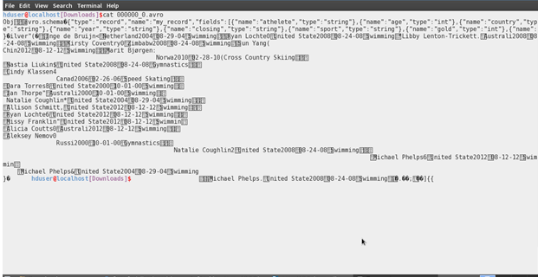

Next I am downloading the avro-tools-1.7.5.jar which will be used to convert the avro file to a JSon file format

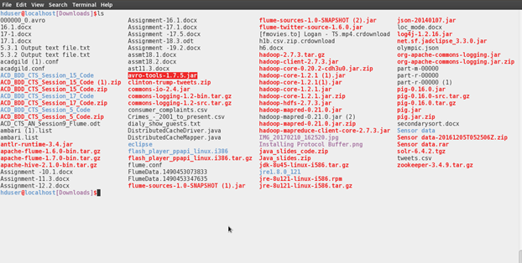

The Command to convert the avro to JSon File type is

java -jar avro-tools-1.7.5.jar tojson 'avro file name' >olympic.json

The Olympic.json file is displayed in the below screenshot.

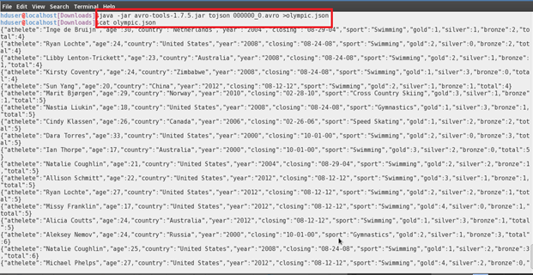

A new File named Olympic.json is created in the Downloads Folder and I’m uploading the json file in the github

